TREE OF LIFE-HAPPY EARTH DAY!
REVISTA ÎN ENGLEZĂ A LICEULUI TEORETIC”BOLYAI FARKAS”
NR.2, 08.04.2020.
Editată de: Puskás-Bajkó Albina

MIHOLCSA GYULA, IX.C
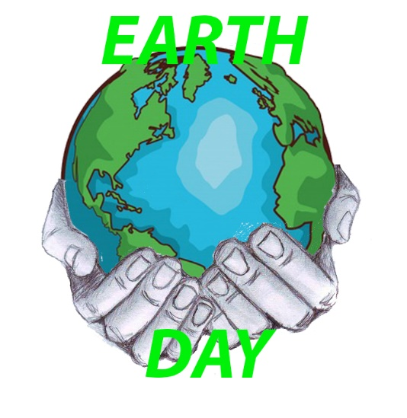
1. It is important to recycle, because resources aren’t endless and not to make into trash.
2. Yes, my family recycles.
3. We are lucky, the Earth provides us water and oxigen.
4. Yes, my family does grow food, and i eat it often.
5. At first there must be a rule to recycle so everyone should follow it. Second somebody needs to be the organizer, we need a system and there should be a way to advertise why is good the recycleing for the school. Finally we’ll need a good director who wants to start this program.
6. In the big cities, a lot of people is sick because of the smoke, and by protecting the air, this problem would be solved. Saving the plants would provide better air. Another big problem is the water, wich is polluted. Because of this a lots of people isn’t healty.
7. I believe in helping the Earth, because it would mean a better life.
8. To gain energy we should use the river, and more solar cells.

9.
Dear Sir,
I decided to write this letter, to draw your attention to save the environment.
You see, in the last decade, our city went on a wrong way and we made a lot of trash and the city is dirty. So the people is living in an unhealty place. I think now is the time to protect the environment.
The inhabitants of the city, including my parents are sick because of the bad air, and the bad water, prooved by the yellow color of this. To start protecting the environment is hard, but it would help very much the people in the town. Everybody would be happy if they lived in a healthy place.
Last but not least, we must pay attention for the place where we’re living. The animals and most importantly the plants are in great danger, and if we don’t do anythiny our healt will be in danger.
I hope, my ideas are good enough to achieve them, and you should pay attention to this problem.

With all due respect,
Miholcsa Gyula-Zsolt
10. In our days is necessary to own a car, because travelling with bicycle is a danger caused by the cars, but the countries should make a change.
11. Today, I will plant trees for the Earth.
12. I see the effects of pollution, when I walk on the streets or go to forests, watch the TV about environmentally friendly locations.
13. Slogans: Help nature!
Try another perspective!
The nature needs your attention!
Bee the hero of your clean nature!
Don’t throw away, recycle!
14. When I recycle, I feel better, because I helped the nature.
15. We can use fewer natural resources if we don’t throw away the objects wich are little demaged, or we try recycleing.
16. I think we can recycle the plastic, the wood, metal, caoutchouc, glass and textil.
17. I am thankful for natural resources, because our life is based to them.
18. We can teach people about the environment in the school, university, by posters, or with the books.
19. Some great strategies for the environment are machines wich use the wind, the sun or the water to create energy, planting trees in cities or recycling.
20. Technology can be good for the environment if we don’t use it against the nature, and we use the knowledge to protect it.

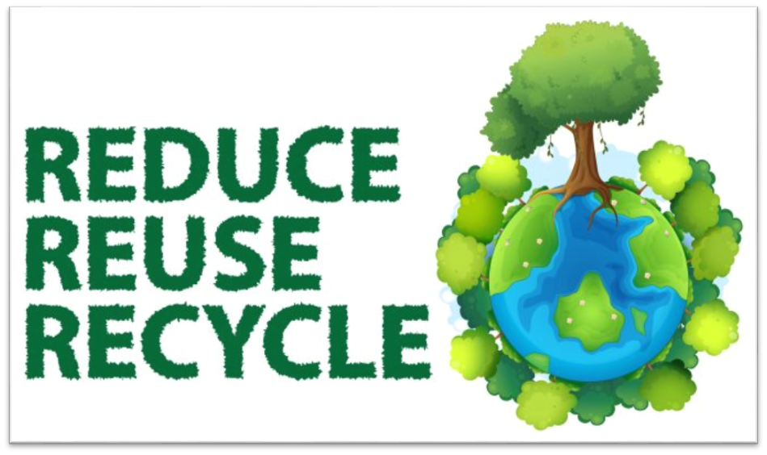

SZABÓ SZILÁRD, IX.G

Earth Day Journal
Day 1: I started to recycle with more attention than before!
Day 2: I appreciate that my family are recycling and take care about the Earth.
Day 3: Is important to recycle to have a beautiful country and to have cleanliness everywhere.
Day 4: I’d like if our city will be clean like the forest.
Day 5: I’m very happy, because we have a garden and we can grow some food for our family. It needs some work but it has the result.
Day 6: We are lucky because the Earth provides us with his simplicity.
Day 7: I’d like if our school will start recycling.
Day 8: I convince my class to recycle and it gone very well.
Day 9: If people take care about the environment, our lives will be healthier than in this days.
Day 10: We must to stop the pollution, or at least to make a law for the cars which pollution is high.
Day 11: I wrote a letter for our mayor to help the Earth with recycling.
Day12: I believe in helping the Earth because I want to have a better life.
Day 13: Today I saw the effects of pollution, because I saw a big cloud of smoke over the city.
Day 14: My school principle heard about our class, and he’d like it if the school recycled too.
Day 15: We don’t help our city if we don’t remove some cars, because the pollution it’s on the rise.
Day 16: The people changed a little bit and accepted that is important to recycle.
Day 17: Everybody wants to have a healthier life and take care about it, that’s what I wanted.
Day 18: The city is cleaner than the last 2 weeks.
Day 19: We removed some cars and this slowed down the pollution.
Day 20: We are awesome because we have a healthy life.

Slogans: 1. Technology always will help us to recycle, so let’s start it!
2. Recycle to have a better, healthier life!
3. Teach your friends how to recycle and take care about they will do it!
4. Think about a way to stop the pollution!
5. Take care about the environment where you live!

Earth Day Journal

Dear Readers, on the next two pages, you are going to read a 20 questions long interview with short answers, with Mr. Jonathán Adorjáni, a local, about the environment, the Earth. We wish you all Happy Earth Day!
- Good Afternoon, Mr. Adorjáni! Are you ready for the interview?
- Good Afternoon. Yes, I am. Let’s start!
- Why is it important to recycle?
Recycling is one of the best ways for you to have a positive impact on the world in which we live. Recycling is essential to both the natural environment and us.
- Does your family recycle?
No, we don’t recycle. We think that in Romania, in our country, this option is not really possible.
- We are lucky the Earth provides us food, shelter, air, and basically everything we need to survive. For the Earth to survive, we must keep these things alive and work with it to be a part of it, to be in harmony with where we live, not against it.
- Do you think your family could ever grow some of your own food?
Definitely! We actually grow some of our own food.
- What are five ways our school could start recycling?
The school should reduce paper use, and it should use more digital devices instead. Also, if using paper, they should recycle the document and use recycled paper. They should also refill plastic bottles instead of letting scholars throw away plastic cups to buy new ones. They also could compost food waste. Finally, it should also help in recycling batteries.
- How could saving the environment make people healthier?
Inevitably, and logically. What is bad for the environment is terrible for us too. For example, By not burning fossil fuels, improvements in air pollution will be gained, and respiratory disease reduced. Encouraging more active transport, such as walking and cycling, will cut down on both transport emissions and we'll be healthier and fit that way.
- I believe in helping the Earth because, most importantly, it is the only home we have. It also provides us food and water and all the things we need.
- What policies could our city make to save energy?
The city should use energy-efficient solutions. Like renewable energy.
- Write a letter to a local politician about the importance of saving the environment.
Dear Mayor,
I am a local worried about the environment, and I am writing to you about the importance of saving the environment. I honestly think there should be concrete steps taken to protect the environment. As this is a letter, which you'll read or you will not, so instead of writing all my ideas down here, I am asking for a meeting with you.
Thank you very much!
Faithfully,
Jonathán Adorjáni,
a local
- Is it necessary to own a car?
In my opinion, this is an absolutely relative question. I think that in this country, it is highly essential to have a car, but if public transportation would be better, owning a car wouldn't be necessary at all.
- Today, I will DO and ACT for the Earth.
- I see the effects of pollution whenever I visit a busy road or a big river. It's incredible how much does the cars pollute. Also, it's a sorrowful scene watching a grey because of river pollution.
- Create five Earth Day slogans to promote recycling.
- Keep the Earth clean!
- Do what you can, and save the Earth!
- Think Green & Recycle!
- Choose the RIGHT planet to live in!
- Earth Mum wants less litter!
- When I recycle, I feel happy and glad, because I am doing something to save the Earth!
- How can we use fewer natural resources?
By a few easy steps, even you can reduce the use of natural resources! Conserve Energy! Conserve Water! Reuse and Recycle!
- Make a list of everything you can think of to recycle.
If I'd make a list of literally everything that can be recycled, it'd be some pages long. So, I'll specify just a few things (the most common ones). These are junk mail and cards, books, the paper we don't need anymore. But also disposable plates and cups, cardboard, batteries, old electronic devices we don't need anymore, etc.
- I am thankful for Earth’s resources because we can live thanks to those. Air, water, plants, animals, etc. – all are vital to us.
- How can you teach people about the environment?
I think we can teach people about the environment in several modes. The most successful and popular method nowadays is online learning, online courses about the environment, but campaign events may also work.
- What are some great strategies for the environment that are already in place?
There are very few great strategies in place already. One of them is the regulation of cars using in bigger cities like London, Paris, etc. Cars do pollute a lot.
- How can technology be good for the environment?
There are quite a few ways technology is helping the environment. The most important of them is renewable energy. Electric cars and smarter homes are also significant.

- These were the questions. Mr. Adorjáni, thank you for the interview!
- I am happy I could answer. Have a beautiful day!

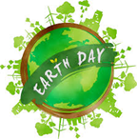

Earth Day Journal Entries Salat Tamás 9.G

1. Why is it important to recycle?
For me it is important to recycle because it helps us in not wasting resources. It makes our lives and our surroundings healthier.

2. Does your family recycle?
Unfortunately, my whole neighborhood does not recycle. This lack of awareness is not the citizens fault, it is the major’s fault, because he does not put recycling bins on the streets of the city.

3. We are lucky the Earth provides us with…
We are lucky the Earth provides us with everything we need in order to survive and enjoy our lives on it. It provides us with both shelter, materials for tools, all kind of food and resources.

4. Do you think your family could ever grow some of your own food?
Yes, I do think my family could grow some of our own food, for your interest, we actually do grow some of our own food, we have little garden in the backyard of our house, where we grow grapes and green onion. But unfortunately, not everybody lives in houses with backyards or in houses at all, most of the population of the city lives in block of flats, where they can’t grow food.

5. What are five ways our school could start recycling?
1. We could start recycling just by putting recycling bins on the schoolyard.
2. The school could collect the plastic and metal and bring it to a recycling station.
3. This way is already active. We are refilling markers.
4. The school booth could start selling recyclable water and soda bottles.
5. The school’s kiosk could package the warm food it’s selling, in paper bags instead of plastic ones.

6. How could saving the environment make people healthier?
By saving the environment we clear the air then we “sterilize” our environment, which makes us healthier too.

7. I believe in saving the Earth because…
I believe in saving the Earth because, this planet is where we live and if we don’t take care of our environment, no one else will.

8. What policies could our city make to save energy?
The first and best thing our city could do in order to get closer to saving our environment and health, the city could close up the fertilizer factory, and second, the city could build a sun power collecting station so that we could have backup energy.

9. Write a letter to a local politician about the importance of saving the environment
Respected Major,
My name is Tomas, and I am writing to get your attention in the theme of saving our environment. In my opinion the city is overrun by pollution, and the only thing that could make this situation better, would be if you would be as kind to close the fertilizer factory so that we could breathe fresh air and not get sick because of the intoxicated atmosphere.
A citizen of Tg-Mures

10. Is it necessary to own a car?
In my opinion, however it may sound, it is necessary to own a car. Yes, it does intoxicate the air, but it is a necessity on order for us to be able to get in and out of the city, the country.

11. Today I will ______ for the Earth
I am writing this at a time of a global pandemic, so the only thing I can say, is that today I will stay inside my house for the Earth, and this is not actually that bad of an idea. If you think about it , if you are not able to get out of the house that often, you are not able to leave trash all around your environment either, so this is a good break for Earth too to get healthy.

12. I see the effects of pollution when…
As I said earlier, in my city there I a big fertilizer factory that is polluting the atmosphere of the city 24/7, so answer would, that I see the effects of pollution when I go by the factory or when I want to go to the mall.

13. Create five Earth Day slogans to promote recycling
1-“Nature WILL strike back!”
2-“Revenge of the Ozone sphere”
3-“Recycle, Reuse, Modify”
4-“Do, or do not, there is no planet B”
5-“Join the green side!”

14. When I recycle, I feel…
When I recycle, I feel like I’m saving someone’s life with not intoxicating my environment.

15. How can we use fewer natural resources?
In my opinion it is not an option to not use natural resources because with everything we do we need some percentage of natural resources in order to move forward, even to survive.

16. Make a list of everything you can think of to recycle
-carboard
-paper
-plastic
-metal
-ceramics
-clay
-wood

17. I am thankful for four ______ resources, because…
I am thankful for our electricity resources, because otherwise we wouldn’t be able to cook, to get information off of the internet, to entertain ourselves, to operate a machine, and many more things.

18. How can you teach people about the environment?
You can teach people about their or anyone else’s environment just by showing them what nature offered us, how we took that offer and then turned it upside down by using it to my ourselves comfortable while our environment is dying.

19. What are some great strategies for the environment that are already in place?
There are many good things happening in favor of our environment, like recycling, using paper instead of plastic (where we can, at least), building solar, wind powered energy sources, using electrical cars.

20. How can technology be good for the environment?
Technology helped us in many ways over the centuries, but to where it evolved by now can help us achieve greater things. It can help us recycle, collect, reuse, and even save energy sources.

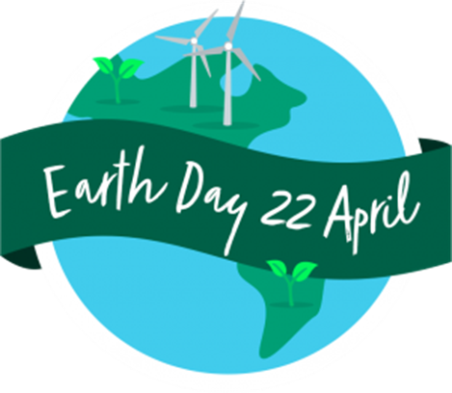

Earth day journal entries

Orbán Gergő, IX.G

1. Why is it important to recycle?
With recycling we can use fewer natural resources.
2. Does your family recycle?
Sadly my family is not recycling yet.
3. Do you think your family could ever grow some of your own food?
Yes, we have a garden behind the house, and we have some vagetables planted there.
4. I believe in helping the Earth because…
I believe in helping the Earth because together we can save the earth.
5. Is it necessary to own a car?
Isn’t necessary to own a car because we can use public transport which is more economical than cars.
6. Today, I will _recycle_ for the Earth.
7. I see the effects of pollution when…
I see the effects of pollution when winter comes, because in the last few years we did not have a really good winter, thanks to global warming.
8. How can we use fewer natural resources?
If we recyle we can use fewer natural resources, and with changing machines with high consumption to low consumption machines.
9. What are some great strategies for the environment that are already in place?
Renewable energy generating with solar cells, wind turbines, water power plants, biomass and with geotermic plower plants.
10. How can technology be good for the environment?
The technology can be good for the environment because with the technology we can create automatic systems, example there is an automatic system which follows the sun and controlls the solar cells direction and this system can produce more energy.
11. Do you think it’s easy to forget to recycle? Why is it so important to remember?
In the start it is easy to forget recycling. It is important to remember because it is good for us and we can clean the seas and the oceans.
12. Do you know of any recycling options in our community?
In our village, there is some recycle bins placed around the village .
13. We must preserve nature because…
We must preserve nature because if we destroy it we can not live longor in the earth.
14. Do you think using reusable bags at stores is helpful and worth the energy they take to make? Yes, because we can use it again and we can save money and resources.
15. How could your family start saving gas?
Changing the gas oven to electric oven.
16. What is the best way to help the environment?
Planting back the trees cut down.
17. Why is littering so bad?
Because there is also poisonous garbage which can call the the environment, and when it goes to the sea or the ocean it can kill many creatures.
18. How could you start saving paper at school?
Using electronic devices to store the lessons.
19. Where do you see the most trash? How does it make you feel?
I have seen on the internet a very big dump and i have got a really bad feeling.
20. Buying things used is a good way to…
Buying things used is a good way to recycle.

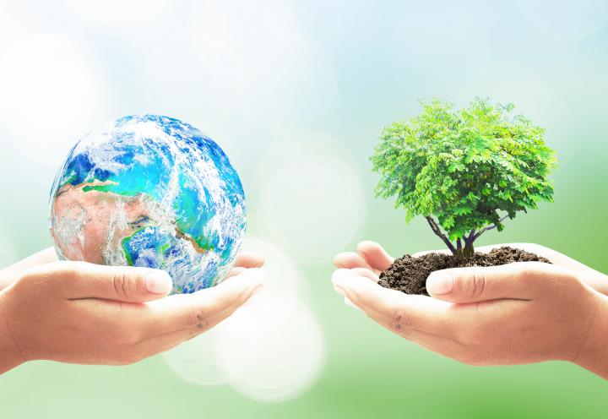

KELEMEN KRISZTA, X.B

Earth day
- In my opinion, it is very important to recycle , because we can protect the Earth, our home only this way. My family and I take care of nature and environment: when I brush my teeth , the tap is closed; and we select the trash etc.
- I think my family could grow some of our own food, because we have got a house and a little garden at village , where we can grow food.
- But I think that is not quite enough. We still need tod o something to protect the Earth.For example,school could start recycling too:support recycling program, start a green team, teaching to love and protect the nature.
- Climate change will also cause have other health threats, such as shifting where disease are found, disrupting food production and spreading air pollution. So we can say, that saving enronment make people healthier
- A healthy planet for healthy people
- It should be bike ride, where kids can calmly and safely go to school, or anybody can go anywhere. It is not necessary , that go everywhere with car. We need to use more bike than car.
- When I recycle , I feel like I did something for Earth and this make me proud of myself.
- Clean up the air we breathe (air pollution is the number one environmental threat to health in Europe, leading 400,000 early death each year)
- Let’s make a toxic-free future!
- The thing that makes my soul very cheerfull is seeing the beauty of this increduble planet! There is so much to see
- ”The Earth does not belong to Man. Man belongs to the Earth.”
- Today I will not pollute the air for the Earth.
- The presence of environmental pollution raises the issue of pollution control. Great efforts are made to limit the release of harmful substantes into the environment through air pollution control,waste water treatment, solid-waste management, hazardous-waste management,recycling
- Pollution is one of the biggest global killers,affecting over 100 million people. That’s comparable to global diseases like malaria and HIV.
- Cleanups can save animals’ lives and discourge people from littering in the future
- Approximately 40% of the lakes in America are too polluted for fishing,aquatic life, or swimming.

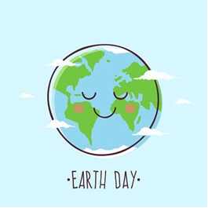

MÉSZÁROS NOÉMI, IX.C

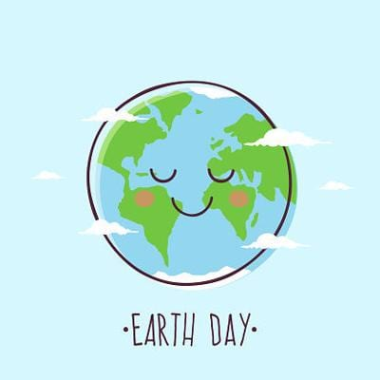
EARTH DAY
- When we recycle, used materials are converted into new products. Recycling helps to protect the environment.
- No, my family doesn’t recycle, because there aren’t recycle bins.
- We are lucky the Earth provides us with beautiful trees, mountains, flowers, animals, forests, oceans, seas, fresh air, and food.
- My grandparents are growing their own vegetables and fruits and we help them too, and they give some to us too.
- Saving the environment make people healthier, because environmental, chemical and air pollution as well as climate change threaten and impact our health.
- I believe in helping the Earth, because it’s the only home we have. We want our kids to have the same beautiful Earth we grew up with.
- No, it’s not, because cars are expensive to buy and to maintain, and also pollute the environment.
- Today I will pick up the trash what I see on the ground for the Earth.
- I see the effects of pollution when it is destroying ecosystems, drinking water, human and environmental health. Not just humans, but also animals can suffer from a number of health problems due to air pollution, including birth defects and diseases.
- Reuse reduce recycle
Remember tomorrow, recycle today Think green, keep it clean Cleaner brighter greener Reuse the Past, and Recycle the Present, Save the Future
- When I recycle, I feel like I’m a better person and I’m helping the environment.
- We can use fewer natural resources if we reuse things or recycle them and this helps to reduce waste and pollution.
- Things to recycle: plastic and glass bottles, cans, paper (magazines, newspapers etc.), cardboard
- I’m thankful for natural resources, because it provides us with all our needs, from the basics of food and water to the many luxuries we seem to enjoy.
- You can teach people about the environment by such as spending time outside and learning to enjoy nature, teach them to reuse and recycle things, turn it off the lights when you are out of the room or stop to water while you are washing your teeth, and give away to others the clothes that you don’t use.

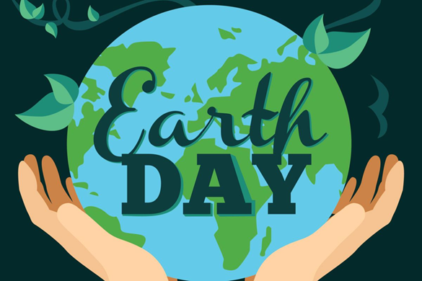

Earth Day
Varga Zsófia, IX.E

1: To protect our planet, recycling is very important. Firstly, recycling conserves resources: when we recycle, used materials are converted into new products, reducing the need to consume natural resources. Another benefit is that recycling helps to protect our environment, reduces pollution and saves energy.
2: Sadly, my family does not recycle, but I often read articles about recycling.
3: We are lucky that the Earth provides us with place to live and with the conditions of life.
4: My family can grow some of our own food. We live in a family house, and we have a garten. It is not too big, but there is enough place for some fruit trees, tomato plants, lettuce, onion, cucumber and ruccola.
5: It is a long way to the succes, if our school starts recycling, but everything is possible. The most important is, that the people need to be interested in recycling. They must know about benefits to be interested, and need to take serious the rules. After these, our school needs recycling bins in every classroom in order to start this moAvement. Then we should try reducing the amount of the garbage. For example we should have drinking fountains to reuse plastic bottles. However without persistent ethusiasm we cannot do anything.
6: Saving the environment includes reducing pollution, so if we save the environment, people can live longer and healthier.
7: I believe in helping the Earth, because people need a place to live, and if we do not realize, that our planet is in danger because of our lifestyle, the life of the humanity will be over. Of course not now, but soon.
8: In order to save energy, our city could use smart street lightning or lamps powered by solar energy.
9:
Varga Zsófia
“local politician”
25.04.2020.
Dear “local politician”,
I am writing to ask for permission to a non-profit movement named “Planet Z”.
The purpose is to show people how important is to save the environment. The name came from the fact, that we do not have another planet to live on, we do not have plan B. Neither Z. “Planet Z” refers to the only place for us to live, the Earth. We need to save it.
The movement includes presentations, that show the current situation compared to the past years, presentations about pollution, enviromentally friendly lifestyle, low-waste products and energy saving.
You can contact me at myemail@gmail.com. Thank you for reading my letter, a positive answer would be a big step for our city to start sving the environment.
Sincerely yours,
Varga Zsófia

10: I think, in most cases in our city people do not need a car. Our city is small enough to walk or we can use the buses, but the second option should be better. If somebody does not have time to walk or to wait, that person definietly needs a car, because in our city do not exist bicycle lanes, so travelling by bicycles is pretty dangerous. In conclusion is not nesecarry to own a car, but is can be really helpful.
11: Today I will reuse a glass for the earth.
12: I see the effects of pollution, when I go outside to the river and see how many rubbish is stucked at the sides of it.
13: “A bottle today, a year in the future”
“Choose the Earth, it choosed you once”
“Save life or pay with it”
“If you poisined your planet, you will be poisoned too”
“If you care, you’ll survive”
14: When I recycle, I feel, that I have done something in order to save the environment.
15: We could use wind power or solar energy in order to use fewer natural resources.
16: I can think of recycle: wased paper, metal tins, plastic bottles, stale bread to bread crumbs, old dresses or books that we do not like anymore
17: I’m thankful for water resources, beause it’s esential for life.
18: We could teach people about the environment if we live a low-waste life and show them, that this lifestyle can be comfortable and helpful to save the planet at the same time.
19: A great strategy for the environment is using cars powered by elecrtcity.
20: Technology can be good for the environment, for example the irrigation can be really helpful to the plants to grow.
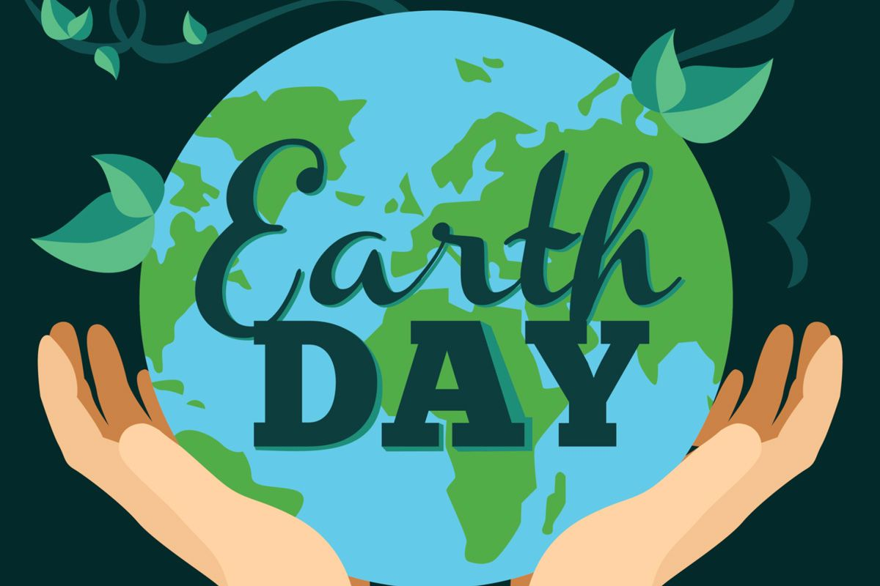

Earth Day
Varga Zsófia, IX.E

1: To protect our planet, recycling is very important. Firstly, recycling conserves resources: when we recycle, used materials are converted into new products, reducing the need to consume natural resources. Another benefit is that recycling helps to protect our environment, reduces pollution and saves energy.
2: Sadly, my family does not recycle, but I often read articles about recycling.
3: We are lucky that the Earth provides us with place to live and with the conditions of life.
4: My family can grow some of our own food. We live in a family house, and we have a garten. It is not too big, but there is enough place for some fruit trees, tomato plants, lettuce, onion, cucumber and ruccola.
5: It is a long way to the succes, if our school starts recycling, but everything is possible. The most important is, that the people need to be interested in recycling. They must know about benefits to be interested, and need to take serious the rules. After these, our school needs recycling bins in every classroom in order to start this moAvement. Then we should try reducing the amount of the garbage. For example we should have drinking fountains to reuse plastic bottles. However without persistent ethusiasm we cannot do anything.
6: Saving the environment includes reducing pollution, so if we save the environment, people can live longer and healthier.
7: I believe in helping the Earth, because people need a place to live, and if we do not realize, that our planet is in danger because of our lifestyle, the life of the humanity will be over. Of course not now, but soon.
8: In order to save energy, our city could use smart street lightning or lamps powered by solar energy.
9:
Varga Zsófia
“local politician”
25.04.2020.
Dear “local politician”,
I am writing to ask for permission to a non-profit movement named “Planet Z”.
The purpose is to show people how important is to save the environment. The name came from the fact, that we do not have another planet to live on, we do not have plan B. Neither Z. “Planet Z” refers to the only place for us to live, the Earth. We need to save it.
The movement includes presentations, that show the current situation compared to the past years, presentations about pollution, enviromentally friendly lifestyle, low-waste products and energy saving.
You can contact me at myemail@gmail.com. Thank you for reading my letter, a positive answer would be a big step for our city to start sving the environment.
Sincerely yours,
Varga Zsófia

10: I think, in most cases in our city people do not need a car. Our city is small enough to walk or we can use the buses, but the second option should be better. If somebody does not have time to walk or to wait, that person definietly needs a car, because in our city do not exist bicycle lanes, so travelling by bicycles is pretty dangerous. In conclusion is not nesecarry to own a car, but is can be really helpful.
11: Today I will reuse a glass for the earth.
12: I see the effects of pollution, when I go outside to the river and see how many rubbish is stucked at the sides of it.
13: “A bottle today, a year in the future”
“Choose the Earth, it choosed you once”
“Save life or pay with it”
“If you poisined your planet, you will be poisoned too”
“If you care, you’ll survive”
14: When I recycle, I feel, that I have done something in order to save the environment.
15: We could use wind power or solar energy in order to use fewer natural resources.
16: I can think of recycle: wased paper, metal tins, plastic bottles, stale bread to bread crumbs, old dresses or books that we do not like anymore
17: I’m thankful for water resources, beause it’s esential for life.
18: We could teach people about the environment if we live a low-waste life and show them, that this lifestyle can be comfortable and helpful to save the planet at the same time.
19: A great strategy for the environment is using cars powered by elecrtcity.
20: Technology can be good for the environment, for example the irrigation can be really helpful to the plants to grow.

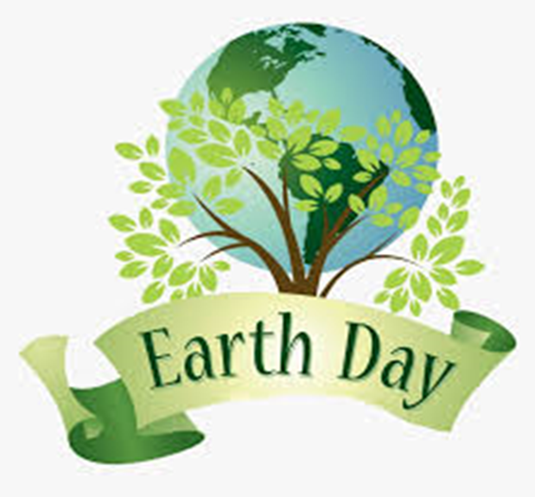
FEKETICS HUNOR, IX.G
International Earth Day
- Recycling is very important, because it is commonly known, that plastic doesn’t decompose too fast, and throwing it away, just to make a new batch, is a big waste.
- Although my family does recycle sometimes, it isn’t much, because there aren’t any recycling bins near us and we can only collect small things like bottle heads.
- We are lucky the Earth provides us with everything we have, even though we only poison it(and ourselves) all day long.
- My mother has many plants, including one that grows tomatoes, one that grows pepper and a quite big lemon tree.
- First of all, our school should have recycling bins, secondly, there should be a group of students who account those who recycle and at the end of every year, and the people who recycled the most should be awarded. Unfortunately, I cannot think of anything else.
- Saving the environment helps reduce pollution, which isn’t exactly the best treatment to our lungs anyway.
- I believe in saving the Earth, because I don’t really enjoy poisoning myself and I don’t think too many people do.
- I can’t think of any policies to save energy, but a more Earth-friendly way of producing it is solar panels.

- Dear Mr. XY,

As you may be aware, our city could use a few improvements regarding the environmental preservation. As you can see through your office’s window, the streets are full of litter. I would like to suggest a course of action. Deploying new garbage cans and maybe even recycling bins, we could greatly improve the health of our citizens.

Kind regards,
Feketics Hunor

- Unfortunately, many people require a car to be able to reach their workplace in time. Public transportation is not the best in this town, and many people dislike it. A good solution would be switching to electric cars, although currently they are way too expensive and there are not enough places to refill them.
- Today, I will play games all they to be honest, but I will keep the lights off.
- I see the effects of pollution, when I see the smoke cars leave behind them, and it is really unpleasant.
- Work for that oxygen you get. Trees need payment too, don’t be selfish. Today’s junk is tomorrow’s epidemic. It’s harder to trip on a clean street. Your dog could be eating junk right now! Better hurry and clean it up.
- When I recycle I feel happy, knowing that I did something for a better future.
- The best way to reduce the need of more natural resources is recycling the ones already used instead of throwing them out.
- I can recycle paper, glass, plastic.
- I am thankful for recycled resources because using them reduces the need of natural ones.
- People should attend a class once a week, where they are shown what happens when no one cares about the environment.
- Some great strategies are laws. In some countries, not recycling is punishable by quite a big fee. Also electric cars are a great idea to reduce pollution.
- Technology can be good for the environment because we can develop more eco-friendly machines, factories, devices and we can improve the quality of recycling.

DÓSA BRIGITTA, IX.C

- The Earth Day
- The Earth Day is an international day, when people talk about Earth and what is the best for this planet. I think many people just talk about health of Earth and don’t work for it. I hope my text will be inspiring for every person in the Earth.
- My opinion is that recycle is very important. If we recycling, we can do new, useful things from the trash. And by recycle, the air and the Earth will be cleaner.
- My family collects garbage selectively. If I make a gift for somebody, I used to do it from “trash”.
- We are lucky the Earth provides us with home, food, oxygen and with the life. Without the Earth we wouldn’t live.
- I live in a town. My family has a vegetable garden and my grandparents have some hens and pigs. I know we can grow some of our own food.
- I think recycle is important in our school. We save the cleanliness in the school and our work too.
- If we don’t throw away the trash, don’t wasting and save the health of the air, we make the Earth cleaner and we will be healthy too.
- I believe in helping the Earth because that is the planet where we live. If the Earth is healthy our life is healthier. If this planet will die, we will die too.
- I think our city is not enough healthy and economy. The leaders of the city should stimulate people to save the energy and the cleanliness.
- People! If we waste the Earth will be dirty. The air will be contaminated and we will be sick. Save the energy, don’t throw away the trash for the Earth. For your life!
- The own cars are more comfortable, but aren’t necessary. Cars make the air dirtier and it is wrong for the Earth.
- Today, I will turn off the lamps in the house and I will pick up the trash for the Earth.
- I see the effects of pollution when I walk on the street, I go to the shop or the school. We don’t save the cleanliness and I see it all the time.
- Make the Earth healthier and do something special. We can do it together. Be creative! Everything is not what it seems!
- When I recycle, I feel I’m a useful person and I can do something for my family, for the people and for the Earth. And I can do something special from the trash.
- We can use the sunrise, the water and the wind to make energy. Don’t use petroleum and natural gas. If we use these things, we put a price tag on the Earth.
- I’m thankful for natural resources, because it make the Earth healthier.
- We show good example for people to save nature.
- The technology usual is not the best thing to the Earth, but we can use it to say what they can do for the Earth and nature. About that the technology will be better for the world.
- I think people do enough bad things for the Earth. They don’t think this planet is going to be for their children. If we don’t save the Earth, our children won’t live in a healthy world.
- Everybody loves the flowers, but few of these think flowers are more beautiful in the mead. See the flowers, don’t pick them.

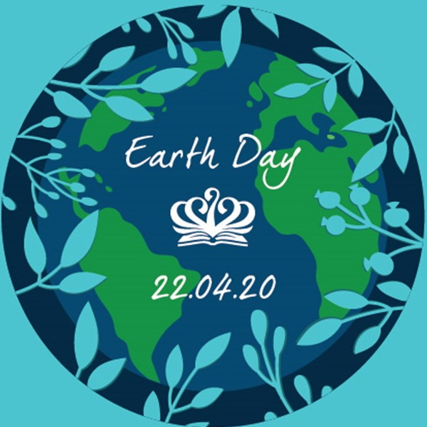
Earth Day

KOVÁTS ESZTER-TÍMEA, IX.C

- Why is it important to recycle?
In my opinion, is important to recycle, because is one of the best ways for you to have a positive impact on the world in which we live. Recycling is important to both natural environment and us.
Recycling benefits the environment in a number of ways. First thing first, the materials and the natural resources aren't wasted and the energy is saved during the process. Not to mention, there's less waste going to landfills and the wildlife is in safe.
In addition, there is well-paying jobs for recycling, for example in the United States 757.000 people got a job.
- Does your family recycle?
Environmental protection is important to me and my family. We use canvas bag when we go shopping, but we haven't tried yet recycling. I think it would be time to try this too, because it's worth it.
- The Earth provides us with air to breath, water to drink, food to eat, space in which to live.
Each of these resources is indispenseble for life.
- Do you think your family could ever grow some of your own food?
Since we live in a house with a garden we grow vegetables and fruits. We really like gardening and I think the fruits and vegetables we grow taste much better then the ones we buy.
- What are five ways our school could start recycling?
Five ways our school could start recycling:
Paper recycling:
Paper is the main type of waste that is produced in schools on an everyday basis. We sholud start off its recycling by getting a paper recycling bin in our school. We shold ask students to put in only paper waste in such bins and inform students about the importance of recycling paper.

Metal recycling:
Another way to recycle that can be done at school. For this too, you will need a metal recycling bin and we should tell students about importance of recycling metal.

Plastic recycling:
Plastic recycling refers to the process of recovering waste plastic and reprocessing the materials in useful products. We should do plastic recycling in school and for this process we have to buy a plastic recycling bin.

Start a recycling project:
Another way to involve students and teachers in recycling at school is to start a recycling project and invite everyone interested in this initiative.

Collect reusable:
Sometimes, we tend to throw away a lot of things which can actually use it again. To recycle or reuse at school, we should ask students to give all reusable things so that the waste can be reduced.
- How could saving the environment make people healthier?
I think, if we were to protect our environment, we would be surrounded by less garbage and cleaner air, which is inevitable for our health.
- I believe in helping the Earth because is the only known planet having life in the universe. So we should respect and everything we get from our Earth. We should save the mother earth so that our future generations can live in safe environment.
- What policies could our city make to save energy?
One of the most important solutions to reduce energy in cities is by offering a variety of public transportation options. This would make fewer people to drive and the air would be much cleaner.
When cities invest in protected bicycle lanes on the roads, people will feel safer riding their bikes. Together, these changes reduce car density and decrease energy consumption.
It would be much better by installing solar panels, which absorb light from the sun and the city would be able to tap into free energy.
- Write a letter to a local politician about the importance of saving the environment.

Dear Sir,

I'm writing this letter to express my views on how government and civil society should join their efforts in order to help with environmental problems. I take pollution and global warming seriously enough to be a problem, and I know we have to take action against it.

Deforestation is also a serious issue. Everyday thousands of trees are cut down and ecosystems are destroyed. Trees do many important things in the environment. They provide the basic needs for life, such as oxygen and water. Without trees the whole environment, ecosystem, would be thrown off balance. We need to take action and stop the destruction of our beautiful forests.

Pollution is growing as a serious issue. Pollution is causing harm to plants, animals, and humans. Many people/animals are affected by pollution every minute. If we don’t act soon, then it might to be too late. We need to put a stop to all of our pollution.

Global warming is a serious issue and is not a single issue but a number of environmental issues. Global warming is a rise in the surface temperature of the earth that has changed various life forms on the earth. The issues that cause global warming are divided into two categories include “natural” and “human influences” of global warming.

In conclusion saving the environment is an important job that we should all be involved in.
If you are of the same opinion, please try to do something about it and please help the environmentalists as well. Remember that this help is needed not only for nature but also for us.

Yours faithfully,
Kováts Eszter-Tímea

- Is it necessary to own a car?
I don’t think anyone who lives in the city close to their workplace necessarily needs a car. However, anyone who lives further away from the city could also solve the commute by public transport.
- Today I will use public transport, instead of a car for the Earth.
- I see the effects of pollution when in the city is smog, which can irritate the eyes and throat and also damage the lungs—especially of people who work or exercise outside, children, and senior citizens.
- Five Earth Day slogans, to promote recycling, is:
- Make every day Earth Day.
- Join the Green Side.
- Green is a way of life.
- Green is the new black.
- Green life is a happy life.
- When I recycle I feel I am happy and proud of myself because I feel like I have done something for our environment, even if only a little.
- How can we use fewer natural resources?
We should conserve energy, water and try to reuse and recycle still usable objects.
- Make a list of everything you can think of to recycle.
- Paper and Cardboard
- Rigid Plastics/Bottles
- Metals
- Glass
- I am thankful for the environmental resources, because I have clean air to breath and I have everything I need for life.
- How can you teach people about the environment?
I think the best way to teach people to take care of our environment is to lead an example for them. We should give away to others the toys and clothes that we don’t use.
- What are some great strategies for the environment that are already in place?
In my opinion, the most useful strategies are the invention of windmills and solar panels, as both solutions are environmentally friendly.
- How can technology be good for the environment?
Smart home devices conserve energy by using artificial intelligence to shut off power to devices that aren’t in use. These smart home devices can also optimize your thermostat or power use so you’re not consuming energy when you’re not at home.
From this we can even conclude that with the development of technology we do not harm the environment at all, in fact, this can be to our advantage.

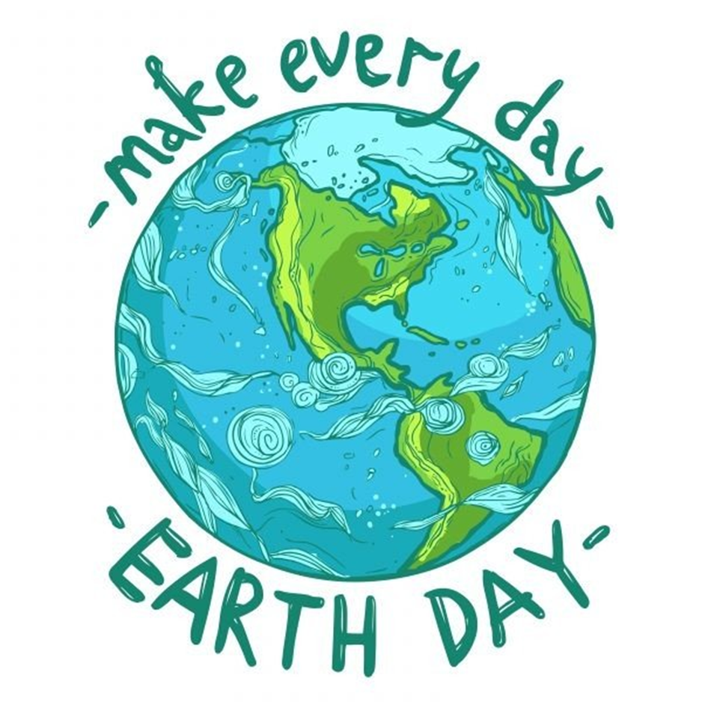

NAGY SÁMUEL, IX.G

- It is important to recycle because with it we can descrease the pollution caused by factories that do not have to make that many products.
- My family doesn’t recycle cause we have no possibility for it in our village.
- We are lucky the Earth provides us with oxigen, water, fruits and vegetables, minerals like oil,carbon.
- Yes, my family always grows some of our own foods like vegetables and fruits.
- In the school we could recycle: reduce our paper use, refill plastic bottles, set up an Eco-Team, recycle high grade paper, recycle batteries, we can use recycling bins.
- Saving the environment could make people healthier because the air would be cleaner.
- I believe in helping the Earth because if every people would do something better it could helps a lot on the environment. A very good example is after in China after the coronavirus epidemic started, less people used cars and the air cleared fast.
- I don’t think cause the policies can make to city to save energy cause that it is depends on the population of the city, but if at night the lights would be shut down then it can saves a lot of energy.
- Dear …,
I write this letter to tell you about the importance of saving the environment, and to ask you to trie to find out some policies what are helping in saving the Earth. We have to trie to do something to avoid this massive polluation, the global warmup. I think you know what situation is in the big cities of China, so I think we have to trie to do something if we don’t want to happen that in our city after a few years.
I recommend to introduce a policies about the recycling and higher tax to factures which are poluating our city.
With respect N.S.

- If you live in a city it is not necessary, but if you live in a village it is good if you have one car.
- Today, I will plant some plants for the Earth.
- I see the effect of the polluation when I go back to city from village, I can feel the aer is much worst then at home.
- We can use fewer natural resources if we don’t use cars just buses, and we don’t turn the lights up all day, or we can trie to use less water.
- I can recycle: paper, bottles, wood, food waste, batteries.
- I am thankful for the oil resources, because it makes possible to travel fast.
- Good strategies that already exist are: planting trees, recycling.
- Technology can be good for the environment if it hepls to keep clear the air, and the water.

TOLVALY ROSCA FERENC, IX.C

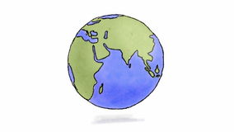
International Earth Day
Why is it important to recycle?
It’s important to recycle, because this way we save our planet.
Does your family recycle?
Yes, my family recycles.
We are lucky the Earth provides us with…
Water, air, earth, fire, all the important elements.
Do you think your family could ever grow some of your own food?
We are already growing lots of vegetables and fruits.
What are five ways our school could recycle?
Not spit your gum out on the road, don’t waste papers, recycle metal, recycle plastic and possibly composting.
How could saving the environment make people healthier?
First off, people wouldn’t get any type of virus/illness so easily, like lung cancer.
I believe in helping the Earth, because…
Earth is in real danger right now.
What policies could our city make to save energy?
They could stop using nuclear power plants.
Write a letter to a local politician about the importance of saving the environment:
Dear Mr. Florea
In this letter, I would come up with a suggestion that could save our environment. That is, to remove the nuclear plant, Azomures.
We must remove this nuclear plant. It causes huge damage to other animal’s natural habitat, including our own health. Please, sir, I would humbly like to ask you, to remove this nuclear plant, and replace it with any other kind of plant, that could be a wind power plant, or water, or whatever healthier than this.
Thank you for reading this letter, and I am hoping you will do the right decision.
A citizen of Targu-Mures.
Is it necessary to own a car?
It’s not necessary, because cars cause a lot of pollution.
Today I will recycle for the Earth.
I see the effect of pollution when…
I see it, when the air gets smoggy, and the air becomes less natural.
Create five Earth Day slogans to promote recycling:
Recycle with a cycle.
Save the Earth for a better place.
Recycle metal for more petal.
No to nuclear plants.
Cars are not a necessity.
When I recycle, I feel…
I feel happy!
How can we use fewer natural resources?
We could start using compost piles.
Make a list of everything you can think of to recycle:
-batteries
-plastic
-paper
-metal
I am thankful for natural resources, because they are healthy.
How can you teach people about the environment?
We could lead children by examples.
What are some great strategies for the environment that are already in place?
I have no idea…
How can technology be good for the environment?
We could create robots that could be used for picking up trash from all across the planet

ORBÁN-BALÁSSY KATA, IX.C

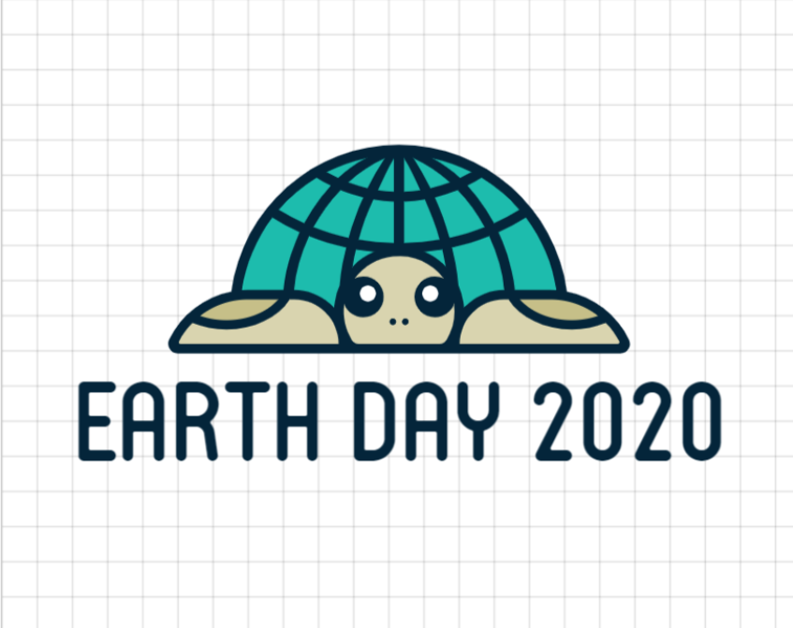
Earth Day
1.We are really lucky that the Earth is providing us food.
2.Do you think your family could ever grow some of the food you eat?
Yes, we have a small garden where we grow our own vegetables and fruits.
3.What are five ways our school could start recycling?
The 5 things our school could recycle are the items, the bottles that could make good things, the garbage that we could pour into a big compost, the jars that we could plant plants in, and the clothes that we’ve already outgrown, they it could be given to an orphanage, as we did at Christmas.
4. How could saving the environment make people healthier?
For example, by driving less by car and more by bicycle.
5. I help the Earth because I want a better future.
6.What policies could our city make to save energy?
I think the best law from an environmental point of view would be to put rentable bikes on the streets, just like in Budapest.
7. Is it necessary to own a car?
I think owning a car isn’t necessary because there is public transport or we can ride a bicycle instead.
8.Today I will save electricity by not using the TV for the Earth.
9.I am grateful for the wind resources because it is much healthier than the other ways of producing electricity.
10.How can you teach people about the environment?
I could make a short film about the environment so it can get people’s attention.
11.What are some great strategies for the environment that are already in place?
I noticed that in most malls, the bags in which vegetables and fruits can be put are already made from recycled material.
12.How can technology be good for the environment?
It would be best if all cars were already running by solar energy.
13.My family and I try to pay as much attention to environmentally conscious life as possible, so we do not use plastic bottles, but we use our own, stronger material bottles.
14.Instead of a plastic bag, we use a special eco bag that can be easily washed out. The bread also has a separate sack, which is also made of cotton. Sandwiches also have a small sachet that is made of easily washable material and the best part is that it does not absorb water.
15.I will not waste water today, and I will only open the tap when it is really needed.
16.I don’t think we should burn plastic because it’s very harmful to the air.
17.I think you can also use recycled paper because it’s just as good as new paper. I’ve tried it and it would really be like writing on a new piece of paper.
18.You don’t always have to wear brand new clothes, you can buy the same good clothes from the used clothes store as in H&M.
19. Our environment could also be protected by going to go to the Mureş riverside, for example, in the summer to pick up rubbish.
20.Instead of a paper napkin, a fabric napkin can be used.

SUBA ORSOLYA, IX.C

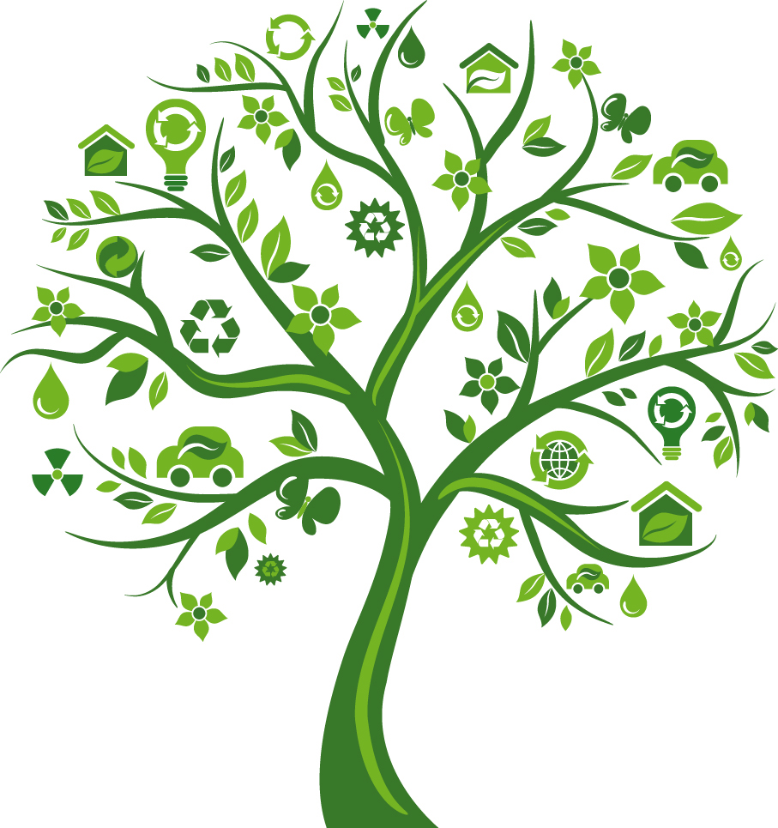
- I want to start recycling, alone I can’t do big things, but I can inspire people to recycle the rubbish, and many people can help.
- We must help the Earth, because it gives us many beautiful places, clean air, living condition, and we are destroying it.
- I want to plant vegetables in tiles.
- We can buy trash cans for recycling in our classroom.
- We can make useful things from our rubbish. For example Gizi from plastic bottle, shopping bags or pillows from our old T- shirts.
- Our school can buy recycling cans for the corridors and in the classrooms.
- We can buy energy saving light bulbs.
- The leaders of the cyties can reward the people who use public transport.
- Today I will write an aticle to the schools newspaper for Earth.
- If people start recycling there will be less garbage in the environment and they will also be healthier.
- I see the effects of the pollution, when in the winter we don’t have snow, and the summers are very hot.
- When I recycle I feel like I did something good.
- WE can recycle our old stuff. We can make something better from them.
- We can use our own flask, to reduce the amount of the plastic waste.
- I think, the biggest problem is, thet in our city there aren’t recycling trash-cans, we must do something about that.
- We can organise school activities to draw attention to the pollution.
- I think, thats good, that we have Inernational Earth day.
- They can be avertisments, like ads, to draw the humanytis attention to the Earth.
- The events should be better advertised.
- There could be school activities in this regard.

